ENDPOINT SECURITY MONITORING

AIM

To understand the fundamentals of endpoint security, endpoint monitoring methods, and tools used to detect and respond to threats in the TryHackMe room “Intro to Endpoint Security.”

PROCEDURE

- Open the TryHackMe room “Intro to Endpoint Security” and study the basics of endpoint security.
- Learn how endpoint monitoring helps detect suspicious activities on devices like computers and servers.
- Understand the tools and methods used for endpoint logging, monitoring, and threat detection.
- Complete the tasks and answer the questions in the room.

QUESTIONS

TASK 2 – Endpoint Security Fundamentals

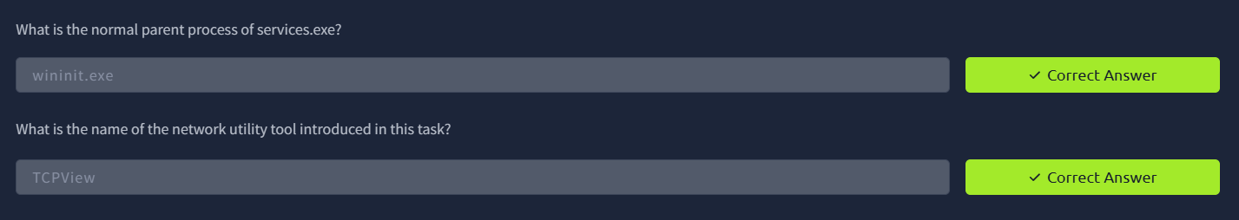

TASK 3 – Endpoint Logginf and Monitoring

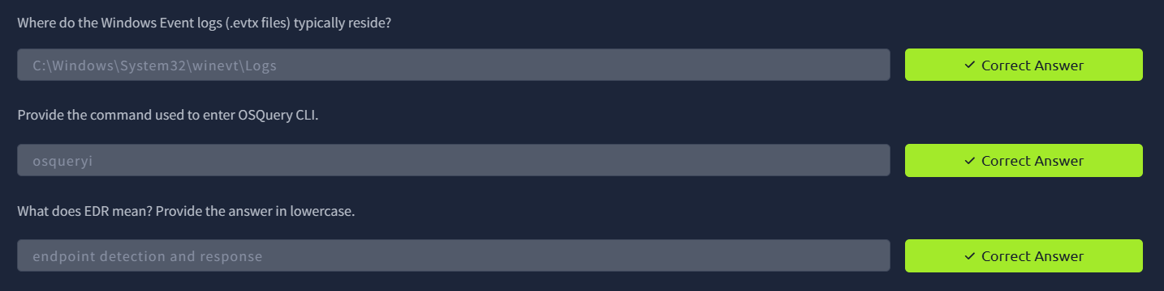

TASK 4 – Endpoint Log Analysis

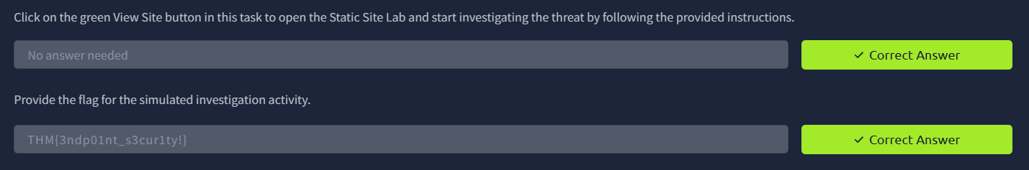

RESULT

Successfully learned the fundamentals of endpoint security, endpoint monitoring techniques, and the tools used to detect and respond to security incidents.

